Lab 6:

1. Create table customer and insert data
2. Display data whose Address is Ayush Address.
3. Display information where buying amount is Gaurav purchases
4. Display all distinct phone no from table.

SQL Query

* CREATE DATABASE db6;

USE db6;



* CREATE TABLE customer(

id INT(3),

fname VARCHAR(30),

address VARCHAR(30),

bamount NUMERIC,

phone NUMERIC);



* INSERT INTO customer VALUES

(1,'Abhilekh','Myagdi',6000,9801234567),

(2,'Alisha','Kathmandu',5600,9876543210),

(3,'Anshu','Mustang',7000,9843027189),

(4,'Anush','Jhapa',3000,9865432109),

(5,'Aslesha','Solukhumbu',8700,9808765432),

(6,'Ayush','Kathmandu',6700,9823456780),

(7,'Barsha','Kathmandu',7700,9832109876),

(8,'Diya','Lalitpur',3000,9808765432),

(9,'Gaurav','Jhapa',3000,9876543210);

SELECT \* FROM customer;

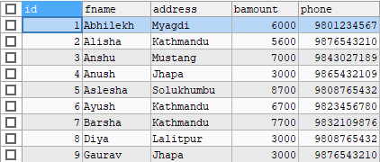

* SELECT \* FROM customer

WHERE address =(SELECT address FROM customer WHERE fname='Ayush');

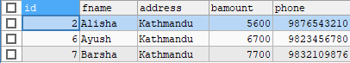

* SELECT \* FROM customer

WHERE bamount=(SELECT bamount FROM customer WHERE fname='Gaurav');

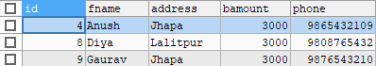

* SELECT DISTINCT phone FROM customer;

